Analyzing forecasting models based on different granularity of time series data.

Lal Singh Dhalia  Trinity College Dublin  dhailal@tcd.ie | Roman Shaikh  Trinity College Dublin  shaikhr@tcd.ie | Aman Ray  Trinity College Dublin  raya@tcd.ie

Abstract—ARIMA and SARIMA are popular forecasting models used for problems like weather and stock price forecasting. These are based on data which have time series distribution. In this paper we analyses the effect of granularity of data on each of the algorithms and try to find the effectiveness based on training the model over a smaller granularity (monthly) and a large granularity (yearly)

Index Terms—ARIMA, SARIMA, Forecasting model, data granularity, time series

Introduction
In this paper we are focusing on forecasting problems that are based on time series data. There has been intensive research done by the researchers in this filed to predict the weather, stock market price and in many fields. Most of the prediction are based on the granularity of the data i.e. if the data collected is having the weekly, monthly or yearly relationship. In this paper we are analyzing the effectiveness of forecasting if done on data captured on monthly basis and yearly basis. Through this paper we are trying to demonstrate two things. Firstly, if the data is analyzed on low granularity level as an example instead on analyzing the data on yearly basis if prediction is done on monthly basis and all the prediction of twelve months are summed up to calculate the prediction for the year it may through a better result and how effective will it be (Ref. [2]). Secondly, we are checking the behavior of two algorithms that we will be using for prediction and will conclude which algorithm is more effective over the time period.

Data Preparation
This project is developed in Jupyter Notebook using Python 3 as programing language. For our development purpose are using the time series data to forecast the number of customers who commute from airport. To do the forecasting analysis its necessary that data should be in time series format, which includes conversion of data into DateTimeIndex. Once the data is converted into time series its necessary to handle the outliers and missing values, which is being handled by removing the row.

SATINARITY AND MODEL BUIDING
We are using ARIMA and SARIMA algorithms [1,3] to forecast the number of customers that are going to commute in the future. Below are the steps that have been taken care before forecasting:
- Trend: From Fig 1 its clearly seen that the data is following the upward trend
- Seasonality: In Fig 1 peaks can be seen easily which means that there is seasonality in the data. Before proceeding further and forecasting we must remove the seasonality.

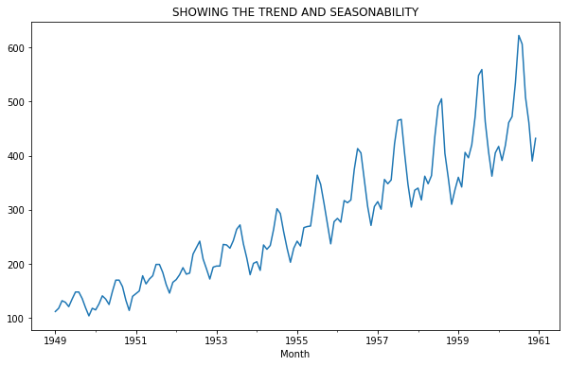
Figure 1: Showing the trend and seasonality in the data.

Data have been modified further to remove the seasonality and stationarity. To achieve the stationarity, moving average, central moving average or weighted moving average can be used. To achieve the stationarity on this we use data moving average concept followed by log transformation.

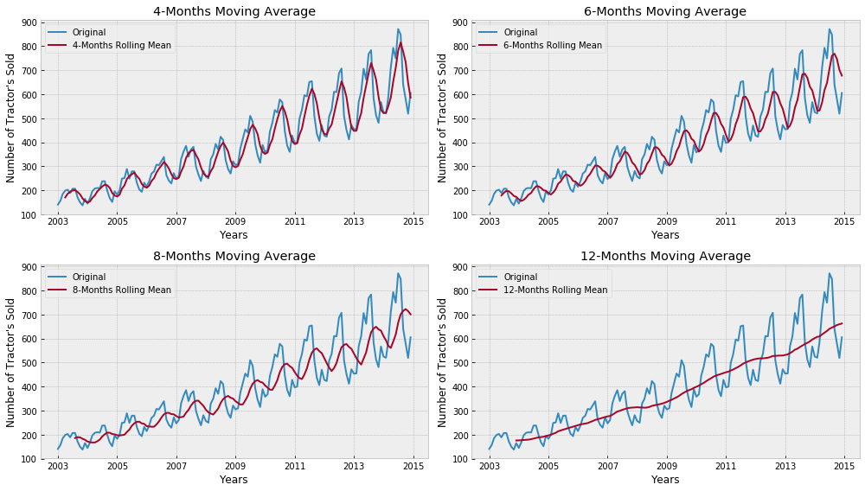
Figure 2: Making data stationary using moving average

To further test the stationarity, we perform the Augmented Dicky test. To check the stationarity, we are comparing the calculated p value against the p value of 0.05. Once the stationarity is achieved the p and q value are calculated using autocorrelation (ACF) and partial autocorrelation function (PACF). The value of d is then calculated using the number of differences that have been done to achieve the stationarity. Based on the p, d, k values the AIC (Akaike Information Criterion) and BIC (Bayesian information criterion) are selected which tells us to what extent the model is reliable. Lesser the value of the AIC more reliable will be the model.

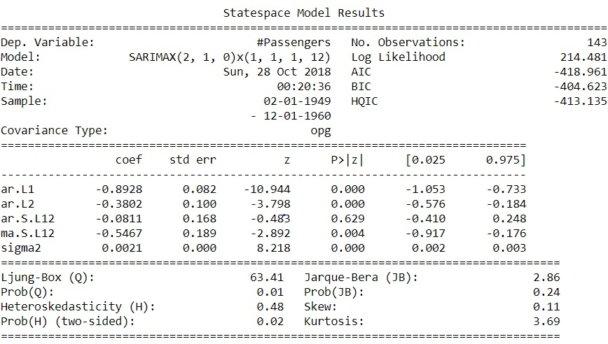
Figure 3: showing the complete State space model for SARIMAX.

FORECASTING/PREDICTION
Once the model is ready the next step is to forecast the data. Here we are forecasting the data for every month in a year. The prediction is done based on the training data. The robustness of the model is further tested by deriving the below charts:

- Standardize residual
- Histogram plus estimated density
- Normal Q-Q plot
- Correlogram

Below figure shows the plot diagnostics for ARIMA model.

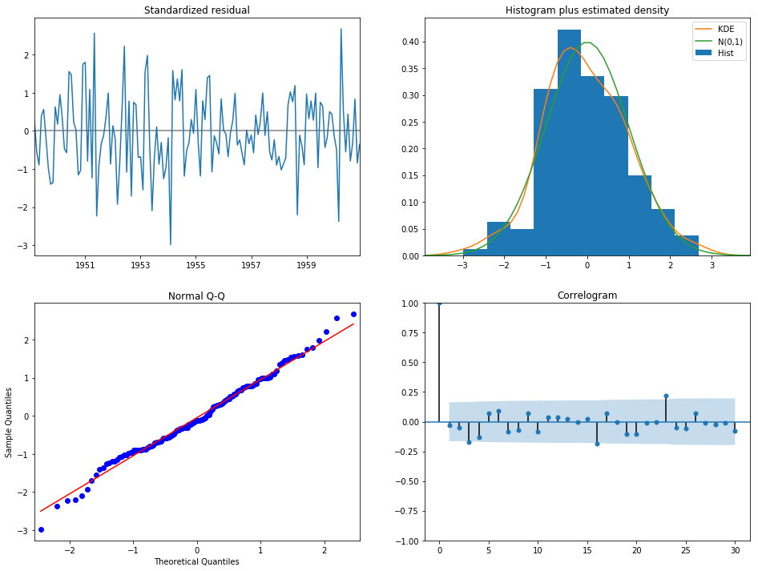
Figure 4: ARIMA model plot diagnostics
We need to ensure that the residuals of our model are uncorrelated and normally distributed with zero-mean. If it is not than it signifies that the model can be further improved, and we repeat the process with the residuals. The KDE plot of the residuals on the top right is almost similar with the normal distribution. The q-q plot on the bottom left shows that the ordered distribution of residuals (blue dots) follows the linear trend of the samples taken from a standard normal distribution with N(0, 1). Again, this is a strong indication that the residuals are normally distributed. The residuals over time (top left plot) don't display any obvious seasonality and appear to be white noise. This is confirmed by the autocorrelation (i.e. correlogram) plot on the bottom right, which shows that the time series residuals have low correlation with lagged versions of itself.

RESULT
Although the prediction done by ARIMA and SARIMA model is following the similar trend with slight difference. To check the reliability of this model we have divided the data into test and train, knowing the prediction of passenger commuting from the airport in future months. The values forecasted by the models are then plotted with actual predictions to check the reliability of the algorithm. Figure 5 and Figure 6 shows the prediction for future using SARIMA and ARIMA models respectively.

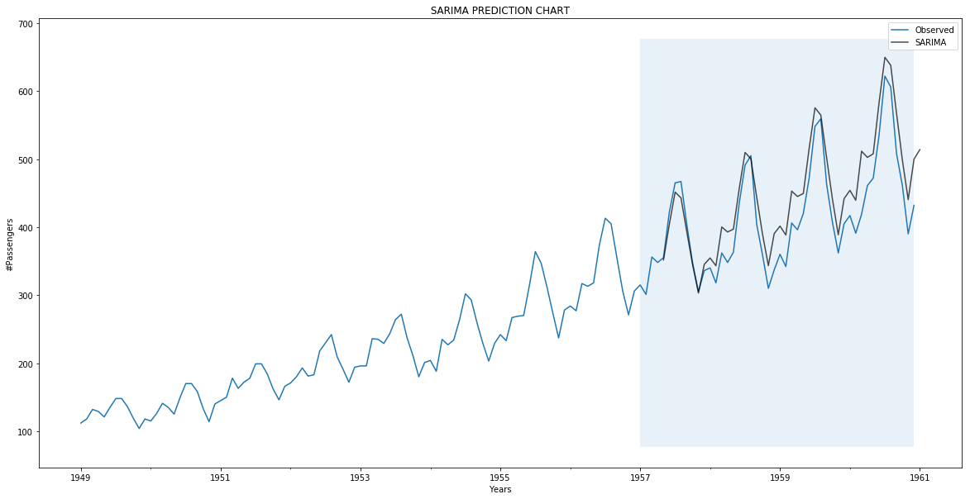
Figure 5: SARIMA future prediction after 1957.

In above Figure 5 blue line is showing the actual observation and black line is showing the predicted value using SARIMA.

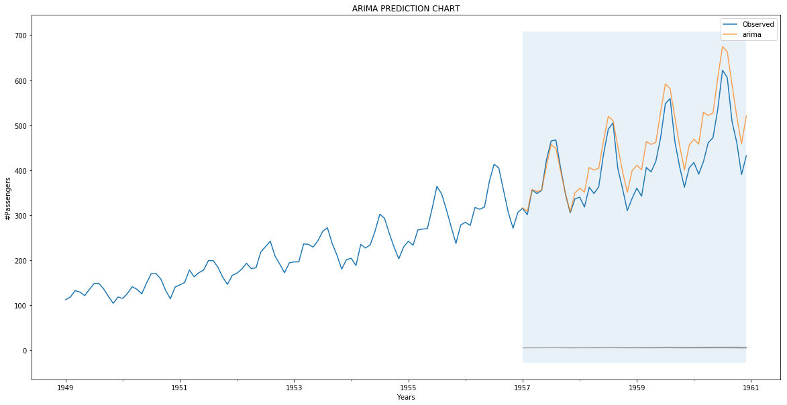
Figure 6: ARIMA future prediction after 1957.

To check how well model worked in forecasting the passenger commute volume for the future months, we have first predicted the number of passenger commute in a time interval with known data. To show the accuracy of the two models over time series data the Mean Square Error (MSE) and Mean Absolute Scaled Error (MASE) are calculated as shown in Table 1 below.
Algorithm | MSE | MASE
SARIMA | 0.0076 | 0.076
ARIMA | 0.0113 | 0.0904
Table 1: MSE and MASE value for SARIMA and ARIMA

LIMITATIONS & OUTLOOK
Missing data is still a big challenge in this filed as replacing with mean average doesn’t land on good forecasting. Moreover, if the data is analyzed based on more granularity level i.e. hourly, weekly would give us more a more robust forecasting model. Although SARIMA model is more effective but finding the prefect pdq value is still a challenge as we must iterate over number of possible value and because of huge mathematical computation it takes time to give best fit pdq with best AIC value.

REFERENCES

- Peter J. Brockwell and Richard A. Davis “Introduction to Time Series and Forecasting,”

- J Joeran Beel “It's Time to Consider "Time" when Evaluating Recommender-System Algorithms [Proposal]”

- Chris Chatfield, “The Analysis of Time Series: An Introduction, Sixth Edition,” Ref. for SARIMA

